Team members: Brennon Franklin, Jessica Evans, Danyal Mahmood.

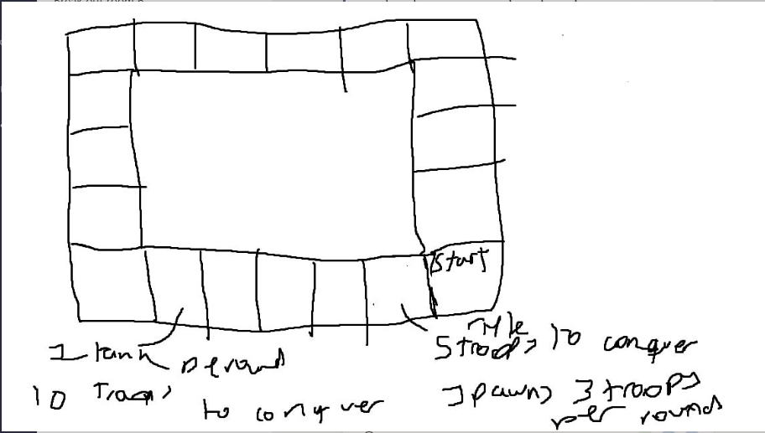The task that was presented to the team was to create a game that revolved around territorial acquisition. After some debate the team decided to create a board game which centred around landing and then conquering different tiles. The basic game idea was that players would collect troops from the conquered territories that would then be used to conquer other territories.

The basic idea was sketched out and the board was then expanded upon by the team. The idea was then improved upon with an attack and defence mechanic for conquering enemy territory and a small number of troops would be created that would each have different bonuses that helped them to conquer enemies at a lower cost. The team decided upon four units with different values, a rifleman that would be worth one point and gain a bonus against rpg wielders, rpg wielders that would be worth three points and have the advantage over tanks, tanks would be worth three points and have a bonus against shotgun men and shot gunmen would be worth two points and gain a bonus against riflemen. Troops would be spawned by captured territories every turn.

The player would move by rolling a 6-sided dice; however, they were not limited to moving exactly the number they rolled and could move any number of spaces up to the number rolled. However, they could not again once they had taken their turn.

The team then decided to include cards that would be drawn by players if they were to land on a special tile and if they were to lose a battle. Cards would either benefit the player or hinder their progress.

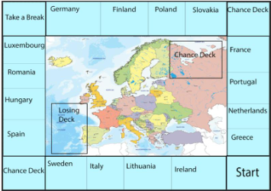

|  |  |  |  |
| --- | --- | --- | --- |
| Ireland   Costs five troops   Gives Three riflemen. | Lithuania  Cost Five troops.   Gives one RPG. | Italy   Costs five troops   Gives one tank | Sweden   Costs six troops   Gives two shotguns and a rifleman. |
| Spain   Costs eight troops   Gives two tanks. | Hungary   Costs eight troops   Gives three Shotguns | Romania   Costs seven troops   Gives two rpgs. | Luxembourg   Costs Seven troops   Gives four riflemen and an rpg. |
| Germany   Costs Twelve troops   Gives two tanks and two shotguns. | Finland   Costs ten troops   Gives 5 riflemen and a tank. | Poland   Costs Twelve troops   Gives four shotguns and an rpg. | Slovakia   Costs ten troops   Gives three rpgs and two riflemen. |
| France   Costs fifteen troops   Gives Five rpg’s and a shotgun | Portugal   Costs fourteen troops   Gives Three tanks and a rpg | Netherlands   Costs fourteen troops   Gives ten riflemen and a shotgun | Greece   Costs fifteen troops   Gives four shotguns and a five riflemen |

Each territory spawned a different number of troops that would be used by the owner to conquer other territories.

Battles would be fought by choosing a number of troops to which the defender would then counter with their own troops. This would continue until one player decides not to expend any more troops. The winner would then gain the territory and get back of troops equal to their superior strength. The troops returned are selected by the winner.

The team was not able to conduct external play testing due to being short on time. This meant no feedback was given. Feedback was given during presentation of the game idea and included the point of giving images and tables correct figure ledgings.